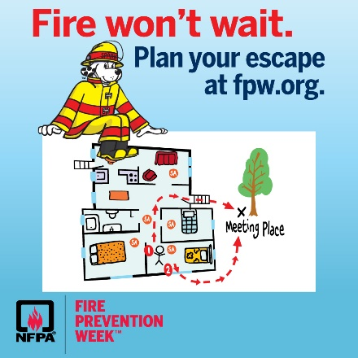
FIRE PREVENTION WEEK PROCLAMATION FOR OCTOBER 9-15, 2022

WHEREAS, the City of Hanahan is committed to ensuring the safety and security of all those living in and visiting Hanahan; and

WHEREAS, fire is a serious public safety concern both locally and nationally, and homes are the locations where people are at the greatest risk from fire; and

WHEREAS, the City of Hanahan is dedicated to reducing the occurrence of home fires and home fire injuries through prevention and public education; and

WHEREAS, residents are responsive to public education measurers and are able to take personal steps to increase their safety from fire; and

WHEREAS, residents who have operational smoke alarms and have planned and practiced a home fire escape plan are more prepared and therefore more likely to survive a fire; and

WHEREAS, the 2022 Fire Prevention Week theme, “FIRE WON’T WAIT. PLAN YOUR ESCAPE.” effectively serves to remind us all of the simple actions that we can take to stay safer from fire during Fire Prevention Week and year-round is an important message for all citizens of the City of Hanahan;

NOW, THEREFORE, I Christie Rainwater, Mayor of Hanahan, do hereby proclaim October 9-15, 2022, as Fire Prevention Week throughout the community. I urge all the residents to develop a home fire escape plan with all members of their household and practice it.

Duly done this the 11th day of October 2022.

__________________________________________
Mayor Christie Rainwater

ATTEST:

__________________________________________
Emily S. Huff, Clerk of Council

