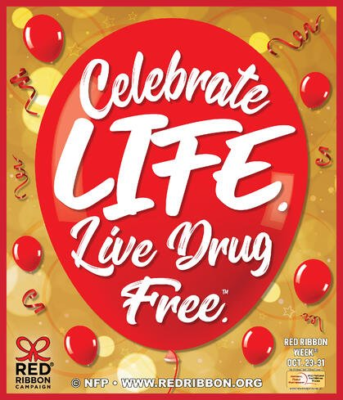
Red Ribbon Week Proclamation – October 23-31, 2022
WHEREAS, alcohol and other drug abuse in our nation has reached epidemic stages; and

WHEREAS, it is imperative that visible, unified prevention education efforts by community members be launched to eliminate the demand for drugs; and

WHEREAS, the Berkeley County Prevention Board is sponsoring the Red Ribbon Campaign offering citizens the opportunity to demonstrate their commitment to drug-free lifestyle (no use of illegal drugs); and

WHEREAS, the National Red Ribbon Campaign will be celebrated in every community in America during “Red Ribbon Week” – October 23-31; and

WHEREAS, Business, government, parents, law enforcement, media, religious institutions, schools, senior citizens, service organizations, and youth will demonstrate their commitment to healthy, drug-free lifestyles by displaying Red Ribbons during this weeklong campaign; and

WHEREAS, The City of Hanahan further commits its resources to ensure the success of the Red Ribbon Week Campaign;

NOW, THEREFORE BE IT RESOLVED, THAT THE CITY OF HANAHAN DOES HEREBY PROCLAIM THE WEEK OF OCTOBER 23-31, 2022, AS:
“RED RIBBON WEEK” IN BERKELEY COUNTY
I, Christie Rainwater, Mayor of the City of Hanahan, do hereby proclaim Red Ribbon Week, October 23-31, 2022. Accordingly, I encourage our citizens to join this campaign as well.
Duly done this the 11th day of October 2022.

__________________________________ __________________________________
Christie Rainwater, Mayor Emily Huff, Clerk of Council

